1. **Agenda**:
   1. Changes in Postman in the Last Year.
2. Postman is in process of changing its testing API and generally its coding API together.
3. 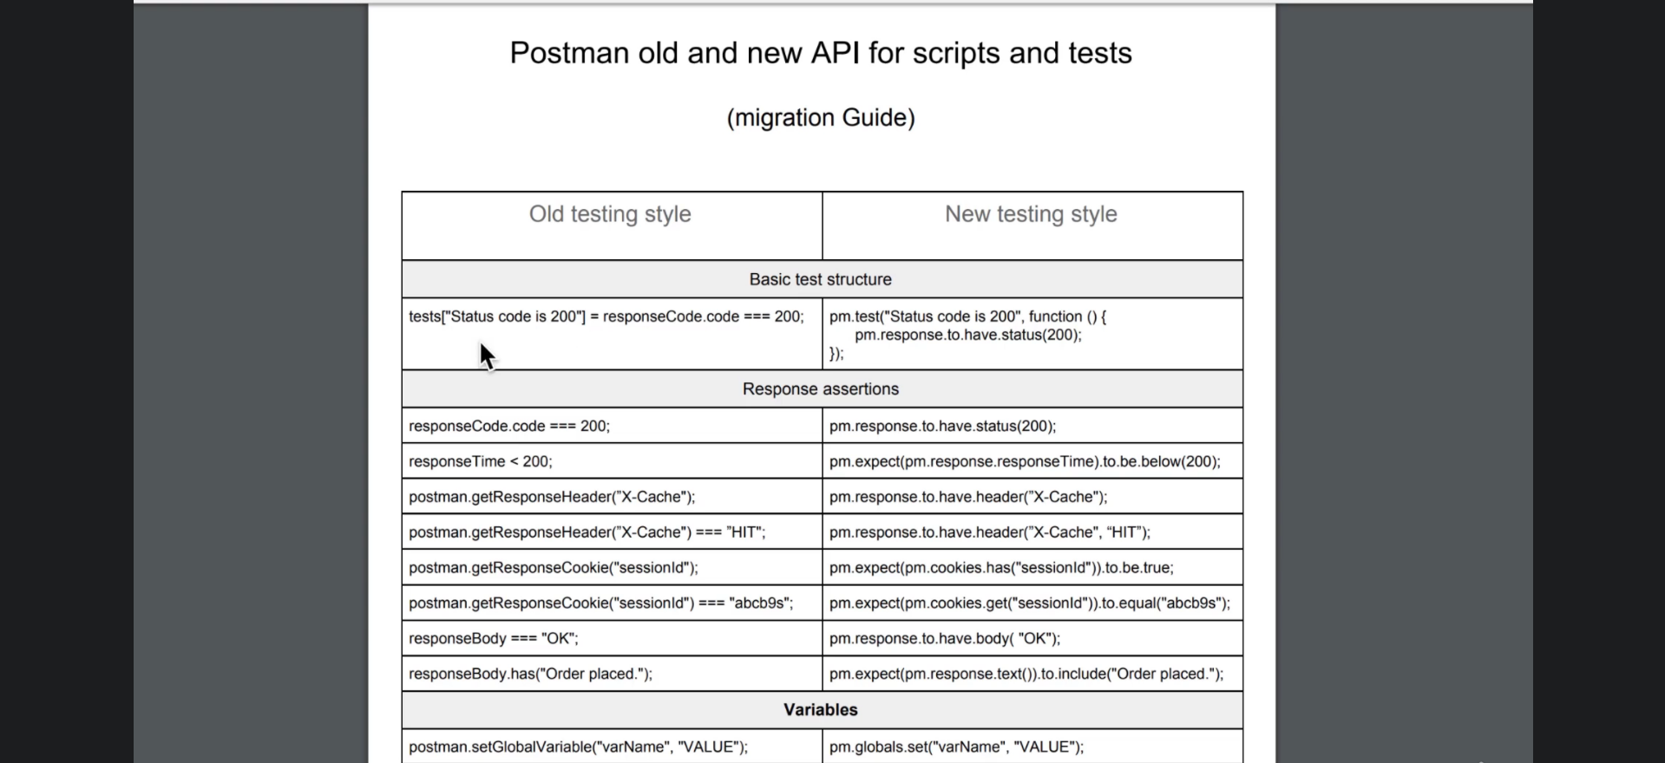
4. Table

   Description automatically generated